

MATHEMATICS 3AMAT/3BMAT SAMPLE EXAMINATION

RESOURCE-FREE

This sample examination paper was developed early 2007 and distributed to all Mathematics teachers as part of the formal consultation process (April–May 2007). The purpose was to provide teachers with an example of how the course syllabus could be examined—specifically the scope, style and difficulty level of the questions that might be asked in a typical Mathematics 3A/3B WACE examination. The sample paper has been further refined following the consultation with teachers, measurement specialists and advice from the Assessment, Review and Moderation (ARM) panel.

The sample paper has been further refined following consultation with teachers, measurement specialists and advice from the Assessment, Review and Moderation (ARM) panel. The major change is that the paper has been divided into two parts—a resource-free examination of 50 minutes, worth 40 marks, and a resource-rich examination of 100 minutes, worth 80 marks.

0000.doc




Western Australian Certificate of Education, Sample External Examination
Question/Answer Booklet

MATHEMATICS
3AMAT/3BMAT
Please place one of your student identification labels in this box.
WRITTEN PAPER
RESOURCE-FREE

Time allowed for this paper
Reading time before commencing work: Five minutes
Working time for paper: Fifty minutes

Material required/recommended for this paper

To be provided by the supervisor
This Question/Answer Booklet

To be provided by the candidate
Standard items: Pens, pencils, eraser or correction fluid, highlighter

Important note to candidates
The standard items listed above and the Resource-free examination paper are the only items permitted on your table during the Resource-free examination. When directed, you will place all other items and the Resource-rich examination paper under your chair.

This paper is for students who have completed Units 3AMAT and 3BMAT as their last pair of units.

Structure of this paper

Working time | Number of questions available | Number of questions to be attempted | Marks
50 minutes | 5 | 5 | 40
 |  | [Total marks] | 40

This paper has FIVE (5) questions. Attempt ALL questions.

Question | Marks
1 | 4
2 | 4
3 | 3
4 | 11
5 | 18
Total marks | 40

Instructions to candidates

1. The rules for the conduct of Curriculum Council examinations are detailed in the Student Information Handbook. Sitting this examination implies that you agree to abide by these rules.

2. Write your answers in the spaces provided in this Question/Answer Booklet. Spare pages may be found at the end of the booklet. If you need to use them, indicate in the original answer space where the answer is continued (i.e. give the page number).

3. A blue or black ballpoint or ink pen should be used.

4. It is recommended that you do not use pencil except in diagrams.

6. Show all your working clearly. Your working should be in sufficient detail to allow your answers to be checked readily and for marks to be awarded for reasoning. Correct answers given without supporting reasoning may not be allocated full marks. Incorrect answers given without supporting reasoning cannot be allocated any marks. If you repeat an answer to any question, ensure that you cancel the answer you do not wish to have marked.

RESOURCE-FREE

This paper has FIVE (5) questions. Attempt ALL questions.

Question 1 [4 marks]
Using calculus and algebra, determine the coordinates of any point/s on the curve 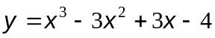 where the gradient is zero.
[4 marks]

Question 2 [4 marks]
Determine the equation of the line tangential to the curve 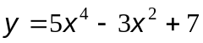 at the point where x = 1.
[4 marks]

Question 3 [3 marks]
Given 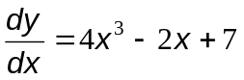 and y = 5 when x = -1, determine y as a function of x.
[3 marks]

Question 4 [11 marks]
The pitch of a pipe in a musical organ (in cycles per second) is modelled by the equation:
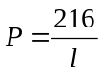 where l is the length of the pipe (in metres).

- Describe in words how P varies with l.
[2 marks]

(b) What would be a suitable domain for l? Justify your choice.
[2 marks]

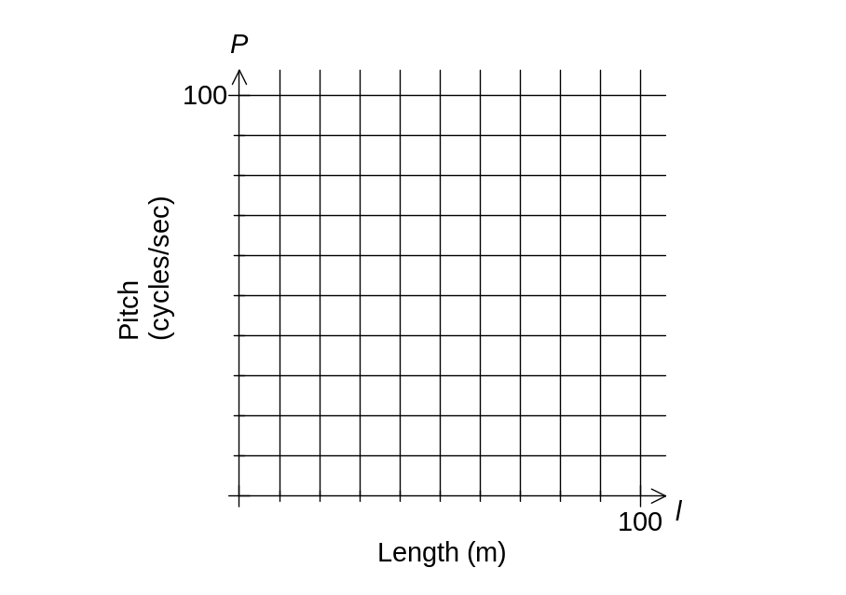(c) Graph the function P, using the axes below: [3 marks]

(d) What is the pitch of a pipe with a length of 3 metres?
[2 marks]

(e) (i) Is P increasing or decreasing as l increases l = 3?
[1 mark]

(ii) What units would the rate of change of P be measured in for the 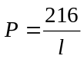 relationship?
[1 mark]

THIS SPACE HAS BEEN LEFT BLANK INTENTIONALLY

Question 5 [18 marks]
To test fitness in a step aerobics class, a student climbs up and down a 0.5 metre step for up to 5 minutes. When the student stops, the pulse rate (r) is taken 3 times after 1, 2 and 3 minutes respectively and a fitness index is calculated using the formula:

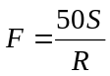,

where S is the time (in seconds) for the exercise and R is the total combined pulse rate from the three readings, (i.e. R = r₁ + r₂ + r₃).

Fitness ratings are given in the following table:

Fitness Index (F) | Rating
F < 60 | Poor
60 ≤ F < 70 | Satisfactory
70 ≤ F < 80 | Good
F ≥ 80 | Excellent

(a) What restrictions are there on S?
[2 marks]

(b) Karl exercises for 4 minutes with the resulting pulse rates, r₁, r₂, r₃ of 100, 80, 70 respectively.
(i) What is his fitness index?
[2 marks]

(ii) What fitness rating would he get?
[1 mark]

(c) Pulse rates (r) are found to be between 50 and 140.
(i) Express this as a restriction on R.
[1 mark]

(ii) Give an example of 3 measured pulse rates after 4 minutes of exercise that would result in a ‘Good’ rating and verify this by calculation.
[2 marks]

The relationship between S and R, when a person is at the boundary of ‘Poor’ and ‘Satisfactory’ ratings are given by the formula: 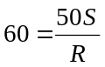 (i.e. S = 1.2R), and this is shown on the graph below:
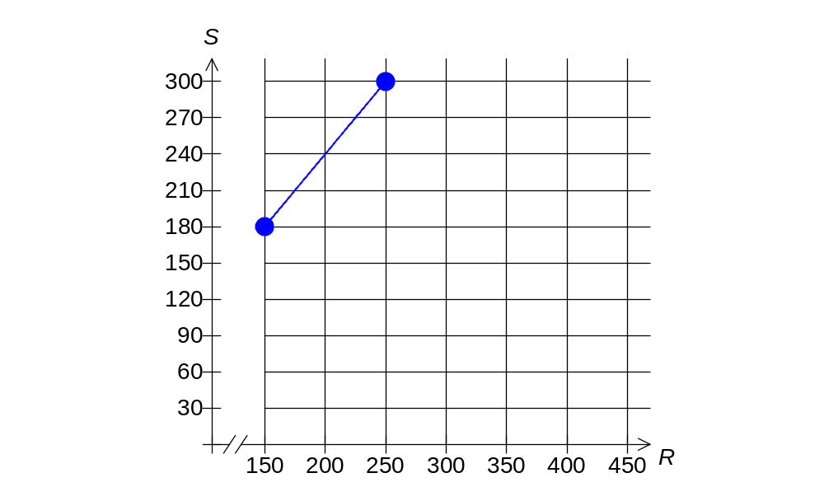
(d) Determine the equation of the line forming the boundary between the categories ‘Excellent’ and ‘Good.’
[3 marks]

(e) Shade the region that represents an ‘Excellent’ rating, on the graph above.
[3 marks]

(f) An extra rating of ‘Very Poor’ is introduced for a fitness index of below 50. Explain why
S = R is the line forming the boundary between ‘Poor’ and ‘Very Poor’ and add this line to the graph above.
[3 marks]

(g) Shade the region on the graph above that represents a ‘Very Poor’ rating.
[1 mark]

THIS PAGE HAS BEEN LEFT BLANK INTENTIONALLY

ACKNOWLEDGEMENTS

Published by the Curriculum Council of Western Australia
27 Walters Drive
OSBORNE PARK WA 6017

